June 30, 2017

Mary O’Connor
19 Shore Road
Chatham, NY 12037-1311

Dear Mary,

Thanks to you, another call for help for recovery from Substance Use Disorder was answered. Due to your generosity, another sole is in treatment and headed to recovery, no longer scared and alone but in a safe place finding help, support and hope.

Thank you for your generous gift of $150 to Columbia County Pathways to Recovery, Inc. (CCPR). Your willingness to help individuals and their families in our County who have succumbed to substance use disorder weather the crises in their lives makes all the difference.

In addition to our help line that reaches out to families in need we also have done great work in education by providing free screenings of important documentaries like “Anonymous People and Dying in Vein, informational tables at many County events and bringing impactful speakers like Chris Herren to our students and community. We also sponsor monthly guest speakers and NARCAN training throughout the County. All this is just the start, we have great hopes to provide a place for recovery and support in our County.

Through our mission we Educate, Advocate, Communicate and Provide Hope. We couldn’t do this important work without you and people like you.

We would love to keep you in the loop with our emails. You can sign up for those at our site, www.columbiapathwaystorecovery.org.

Sincerely,
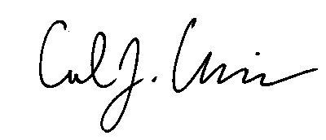
Executive Director, CCPR

As may be requested by the Internal Revenue Service, this letter will serve as your official Columbia Pathways To Recovery, Inc. acknowledgement of your donation. We also confirm that no goods or services were provided to us in connection with this donation. We are a 501(c) 3 nonprofit organization qualified to accept deductible donations under the Internal Revenue Code. Our Federal Tax ID# is 81-4367918.

