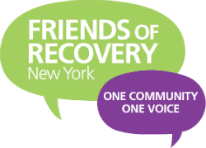

Meeting with Legislators:
Who should you meet with:
Local Senate and Assembly/Find your local representatives here: http://www.elections.ny.gov/district-map/district-map.html
Senators and Assembly Members on committees that we care about including but not limited to Alcohol and Substance Abuse; Education; Insurance; Higher Education; Health and more!
- Assembly: http://nyassembly.gov/comm/
- Senate: https://www.nysenate.gov/senators-committees

Stand Up For Recovery Day Logistics
- Does your region have one appointed leader?
- What is your goal for getting people to Stand Up For Recovery Day from your region?
- Does your region have a bus/What is your region’s mode of transportation?
- How are you communicating and promoting Stand Up For Recovery Day?

